Determining The Best Place for a Vietnamese Restaurant in Seattle

# Introduction

Seattle is one of the United States’s most diverse cities. With a population of over 750,000 people living within the city’s borders, according to U.S. Census 2019 estimates. The population is about 65% white, 15% Asian, 7% African American, 6 % Hispanic, and 7% mixed race. This racial diversity means a variety of food.

One genre of food, Vietnamese food, is considerably popular. According to the British statistics company YouGov, it is the 13th most popular genre of food internationally. There are no food popularity statistics in the United States. However, the non-profit group Visit Seattle has reported that in 2019, an estimated 41 million tourists visited the city. This number combines both domestic and international tourism. With the large tourism numbers, a restaurateur is seeking guidance on the best possible location to open a new Vietnamese restaurant. The restaurateur believes that with Asian Americans as the second largest race residing in Seattle, combined with Seattle’s tourism, would lead to a profitable restaurant.

# Research Question

The research question asked: What would be the best district, defined by zip code, to place a Vietnamese restaurant in Seattle? The restauranteur notes this is a preliminary analysis looking only at physical location. The costs of running such a business would be determined at a later point.

# Requirements

The restauranteur has outlined the following requirements:

1. The data be organized by zip code due to lack of easily obtainable neighborhood data for Seattle.
2. The Vietnamese restaurant is not located in the same district as another Vietnamese restaurant.
3. There is at least 1 major tourist attraction in the same district. This will be defined by Visit Seattle’s Top 25 Tourist Attractions. (See: <https://visitseattle.org/things-to-do/sightseeing/top-25-attractions/>)
4. The restaurant is located within the city boundaries.
5. If there are multiple districts that meet criteria 1-4, the district with the least number of restaurants and bars, including coffee shops, as well as no nightclubs in the top 10 most common venues shall be selected.

# Methodology

The study shall use the FourSquare API to determine the locations that best meet the project requirements. K-Means clustering was originally intended to be used to help analyze the data, but when running the analyses, the clustering did not reveal anything useful, given the criteria of the project. Therefore, k-means clustering analysis information has been omitted from the report.

# Data

The data to be used include:

* Json data for Seattle’s zip codes, as well as each zip code’s median income and population displayed on a map and table (Appendix A)
* Dataframe and map listing Visit Seattle’s Top 25 Attractions, including zip codes (Appendix B)
* Table displaying zip codes with Vietnamese restaurants already within them (Appendix C)
* Map displaying the Seattle Zip Codes and the Vietnamese restaurants labelled in red (Appendix C)
* Map displaying 5 eligible locations (Appendix D)
* Table of top 10 venues inside each eligible location (Appendix E)
* Map displaying the chosen location in a yellow circle (Figure 1)

# Results

When analyzing the data, some of the districts had to be omitted due to the zip code not falling within city boundaries. A table and map of this is shown in Appendix A. Additionally, some attractions from Visit Seattle’s list had to be omitted due to a lack of central location or they were not in Seattle itself. A table and map of the attractions is shown in Appendix B. There were 24 zip codes and 19 attractions that were considered in Seattle.

When looking at purely Vietnamese restaurants FourSquare was able to locate 6 Vietnamese restaurants across 4 districts within Seattle. A table and map displaying this can be found in Appendix C. All 18 attractions were concentrated in 6 districts of Seattle. Among the 6 districts with attractions, only 1 district had at least 1 Vietnamese restaurant within the district and therefore is not eligible for the report’s final recommendations. Therefore, five districts remained eligible. The districts are: 98101, 98108, 98109, 98119, and 98134. A map displaying the eligible districts is shown in Appendix E.

The final criterion of the analysis is that the selected district has the least number of restaurants and bars in the top 10 most common venues, including coffee shops and food trucks, among the remaining eligible districts. A table displaying this information is found in Appendix E. The data indicates that district 98101 has 5 types of restaurants and bars in its top 10 most common type of venue found. District 98108 has 4 types of restaurants and bars within its top 10. District 98109 has 6 types of restaurants and bars. District 98119 has 6 types of restaurants and bars. And District 98134 has 4 types of restaurants and bars and a night club in its borders

# Final Recommendation and Discussion of the Study

Based on the results, the study recommends that District 98108 as the best district to construct a new Vietnamese restaurant (Figure 1). The location selected meets all 5 criteria set by the client. There are currently no known Vietnamese restaurants located within the district, according to the FourSquare API. There is one attraction from Visit Seattle’s Top Tourist Attractions list located within the district. And among all the eligible districts, District 98108 has comparatively less competition the other eligible districts, with only 4 types of restaurants and bars occupying the top 10 most common venues. While District 98134 is tied with 98108 for this distinction, the district also has a nightclub in its area, which makes it ineligible on the final criterion.

Figure 1. Recommended district for a new Vietnamese Restaurant

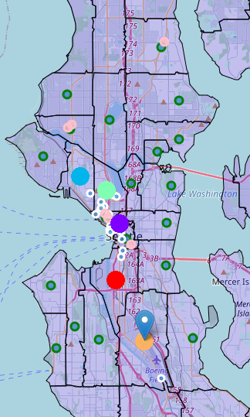

There are several strengths and weaknesses to this study. The main strength of this study is that it draws data from several reputable sources. Visit Seattle is a non-profit organization that is sponsored by the Seattle government as the official tourism organization for the city. This study is also done on behalf of an underrepresented restaurant category for the city of Seattle. The selected location also has comparatively less competition within the district, which may assist in ensuring a stable revenue flow without excess effort.

The major weakness of the study is the scope of the study. The study does not analyze the affect other restaurants within the same zip code may have on the profitability of a Vietnamese restaurant. This limitation, however, is mitigated by the fact that the restaurant in question will be the first restaurant of its genre within that zip code and is not in complete, direct competition with the immediately surrounding restaurants. The next limitation is that the study does not consider the effects of property tax, business tax, or other financial factors into consideration. The study is to strictly analyze physical location. A smaller weakness is that the study relies on FourSquare’s results, which have been found to be limited. FourSquare was only able to locate 6 Vietnamese restaurants across the entire city, while other services were able to locate more. This may be remedied by obtaining access to other geo-locater services.

# References

<https://e.vnexpress.net/news/travel/food/vietnamese-cuisine-among-world-s-most-favorite-3899137.html#:~:text=A%20YouGov%20survey%20finds%20Vietnamese,popular%20cuisines%20in%20the%20world>.

<https://www.census.gov/quickfacts/fact/table/seattlecitywashington,US/PST045219>

<https://visitseattle.org/press/press-releases/seattle-tourism-statistics-announced/>

<https://opendata.arcgis.com/datasets/83fc2e72903343aabff6de8cb445b81c_2.geojson>

<https://www.zipdatamaps.com/zipcodes-seattle-wa>

<https://visitseattle.org/things-to-do/sightseeing/top-25-attractions/>

# Map Description automatically generatedAppendix A: Table and Map of Seattle Districts

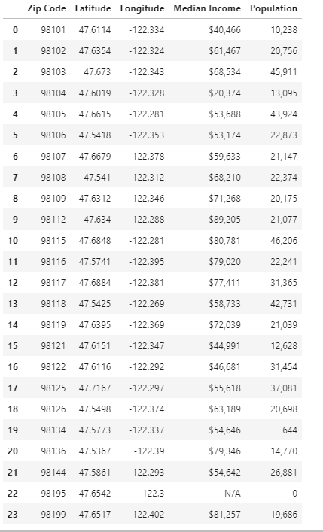

# Appendix B: Table and Map of Seattle Attractions

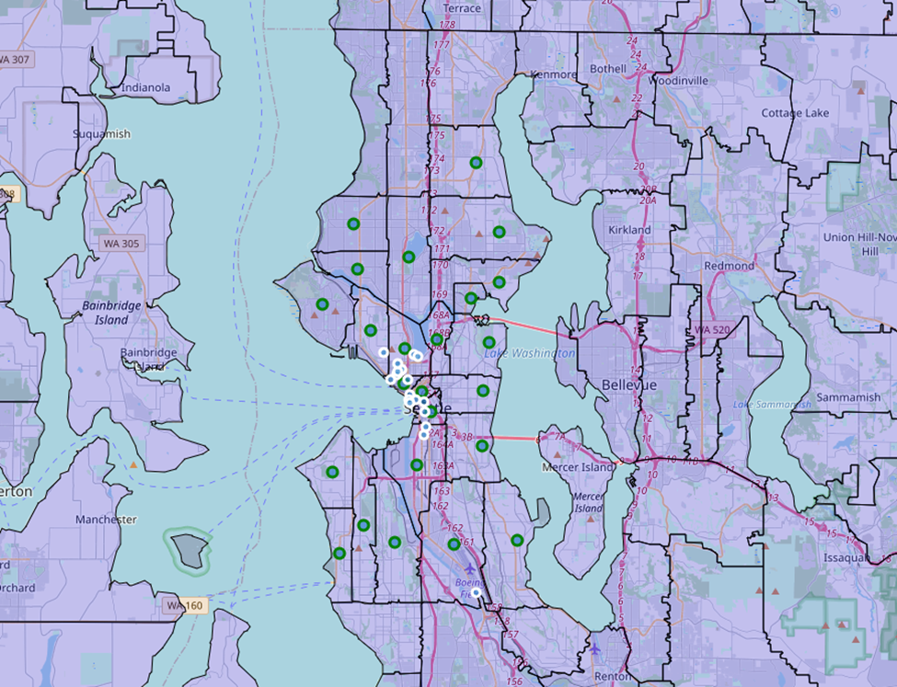

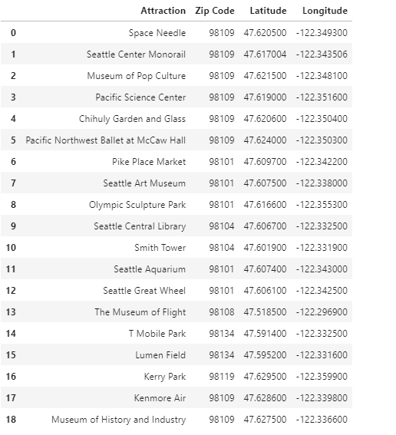

# Appendix C: Map and Table of Vietnamese Restaurants in Seattle

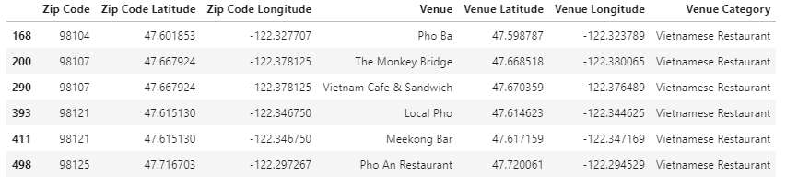

# Appendix D: Map of Eligible Districts

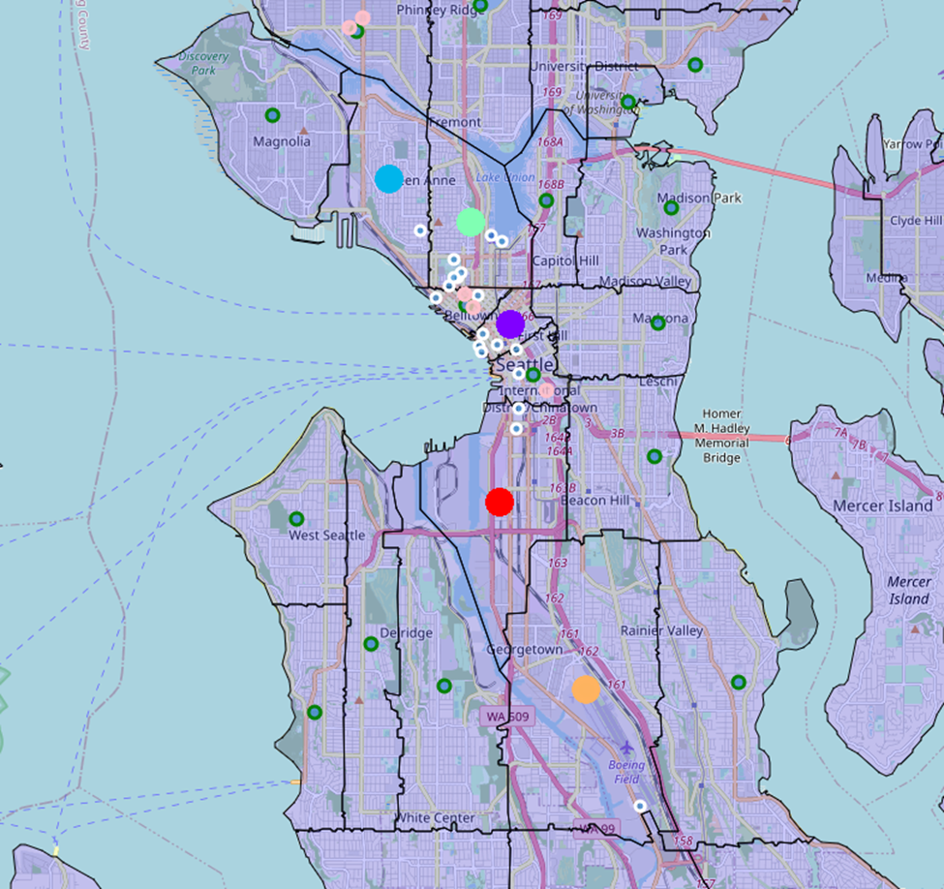

# Appendix E: Table of Top 10 Most Common Venues in the Eligible Districts

